Linux

Name: Mukesh Choudhary

Email: [2018bcamaismukesh6356@poornima.edu.in](mailto:2018bcamaismukesh6356@poornima.edu.in)

Assignment 1:-

1. **When we create a user, some hidden files are generated in the directory of the same user at that time. How is it done?**

Answer:-

* It is done because these files are in the folder /etc/skel and whichever files we place in this folder those files will be made available in the home directory of all the users which we create afterwards.
* For reference following are some commands to create a file in /etc/skel and creating and listing files in /home/userfiles:-

(Note: Make sure you've logged in to root user)

* + cd /etc/root
  + vim abc.txt: Hello I am Mukesh(close the file by pressing :wq and press enter)
  + useradd Alpha
  + ls /home/Alpha
  + Now you'll find the abc.txt document in this folder which is the proof that whichever files we put in the folder /etc/skel will be available to all the users created after it.

1. **Make subdirectories inside a parent directory by using single mkdir command (refer figure given below)**

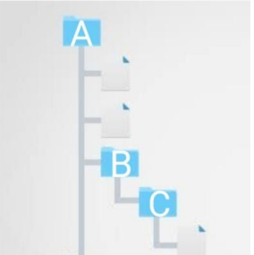

Answer:-

* mkdir -p A/B/C (-p for parent directoy option).

1. **tac command vs cat command**

Answer:-

* **cat :**Cat command, acronym for Concatenate, is one of the most used commands in unix systems.
  + cat file.txt
  + cat file1.txt file2.txt file3.txt
  + cat file1.txt file2.txt file3.txt > fileall.txt
  + cat file4.txt >> file-all.txt
* **tac:** A lesser known and less used command in unix systems is tac command.
  + tac file-all.txt
  + tac file-all.txt --separator "two"
  + tac /var/log/auth.log
  + tail /var/log/auth.log | tac

Assignment 2:-

1. **change the Umask value for any user permanently.**

Answer:-

* To change the umask value type the following command:-

>umask 0234

This will change the umask but it changed on temporary basis, means after you logout it will reset to previous one.

* To change umask permanently goto /etc/bashrc or /etc/profile with root user.
  + Then change umask default value
  + Now the new value is our permanent umask value.

1. **add a new user without using adduser & useradd command.**

Answer:-

* Add an entry of user details in /etc/passwd
  + root>nano /etc/passwd  
    user:x:501:501:test user:/home/user:/bin/bash
* Add an entry of user details in /etc/group
  + root> vi /etc/group  
    user:x:501:
* Assign a password to the user
  + root> passwd user  
    Changing password for user user.  
    New password:  
    Retype new password:

1. **Can we change the Umask value to 0888. If yes, then how. If no then why ?**

Answer:-

No.

Because umask determines the permissions for newly created file file subtracting it from the permission 777.

Like if we have umask 0023 for a user

Then the created directory set permissions are:-

777

-023

754

Means, drwxr-xr—for that directory.

So, if we take umask as 0888 then, it will be “octal number out of range” error.

As it give permission value in negative which is not possible.

1. **how to add a new user with a Unique user id (e.g 1345) & check out the unique Id of that user.**

Answer:-

* To create a user with a Unique user id type the following command:-
  + >sudo useradd –u 1500 mukeshc
  + This will create a user “mukeshc” with unique id “1500”
* To check out the unique Id of that user:-
  + >id –u mukeshc
  + This will show us the Unique id of “mukeshmc” ,i.e., 1500

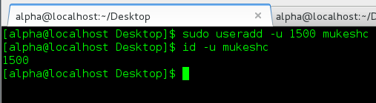

1. **How to change the group of any folder**
   1. **After this checkout the group name of the files present in that folder.**
   2. **Try to change the group of the folder & the files present in the same folder using a single command**

Answer:-

* To change a group of a folder(asdf):-
  + >sudo chgrp mukesh asdf
* To check out its group type command “**ls –l’**

1. No. The group name of the files present in “asdf” folder is not changed.

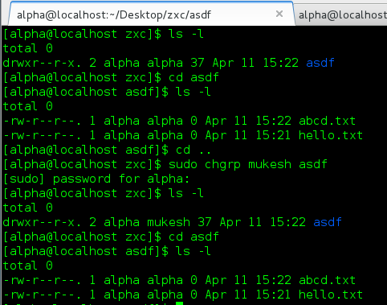

1. Now to change the group name of a directory “myfolder” command:-

* >sudo chgrp –R mukesh asdf
* This command change the group name of directory as well as all the files that are contained in that directory.

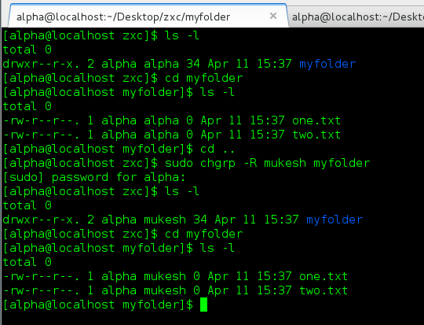

Assignment 3:-

1. **Create & compress the file with bzip2.**

Answer: tar -ram ContentFile.tar.bz2 content.txt

1. **What should be the argument to be given to unzip that file.**

Answer: tar -ram ContentFile.tar.bz2 content.txt

1. **Read a file & show the data on terminal using file input & output redirection.**

Answer: cat < file

1. **How to change the shell of user to “/bin/sh” at the time of adding the user**

Answer: useradd -s /bin/sh username